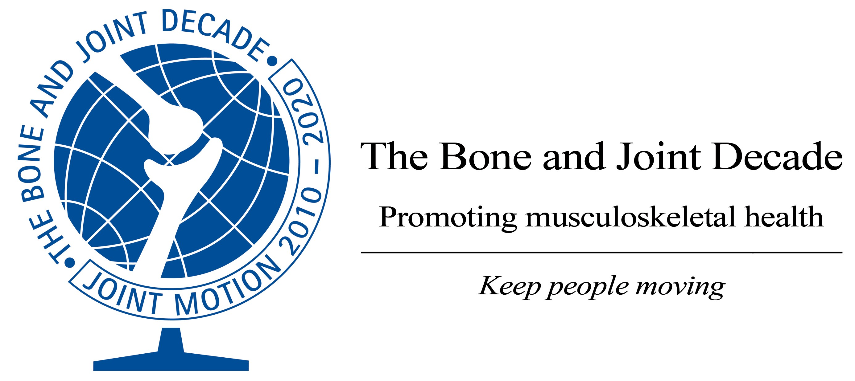 |  | Bone and Joint Decade 2010-2020  Global Alliance for Musculoskeletal Health  World Network Conference 2012
14th May 2012

Dear President
Working Better Together
Ho Chi Minh City, Viet Nam
30th November - 2nd December 2012

We hope you or a colleague will be able to participate on behalf of your organisation in this strategically and scientifically important meeting, aimed at maintaining the momentum of the Bone and Joint Decade in order to raise the priority of musculoskeletal health and science. We would also appreciate you promoting this meeting to the leadership of your member organisations.

It is our aim to ensure that musculoskeletal conditions are among the leading major health concerns in the minds and actions of opinion formers throughout the world and for musculoskeletal health to be a public health priority. This will improve the outcomes for people with these conditions, many of whom across the world do not have access to appropriate care. We hope that you will play an active role in the global alliance that will achieve this.

The meeting will provide a forum for top opinion leaders in bone and joint health, the World Health Organisation, with participants from leading societies, journals, and the Decade’s 70-country strong network. It will also provide an opportunity for a summit of leaders in South East Asia to look at ways to shape the future of musculoskeletal health in their countries.

The meeting will focus on identifying the opportunities and benefits there are from working together, both between professions and disciplines but also across countries. The key opportunities will be identified in the different settings across the globe, recommendations proposed and action plans developed. The discussion will be informed by expert presentations.

Part of the programme will be dedicated to an Educational Symposium to review the team management of musculoskeletal conditions by experts from multiprofessional and multidisciplinary disciplines.

A Summit Meeting will also be held for key opinion leaders from South East Asia to consider and agree how to work together nationally and regionally to advance the priority for musculoskeletal health and science in the region with the potential to form a BJD Regional Forum.

The meeting programme and further information will soon be available on the website www.boneandjointdecade.org and will be distributed via email.

Please let us know if you are interested in participating or can recommend a colleague to represent your organisation. Please reply to myself at bjd@cornwall.nhs.uk

Please also advise us on any ways of improving our communication to the physical therapy organisations in the Asia Pacific region.

We look forward to hearing from you and hopefully meeting you in Ho Chi Minh City, Viet Nam later this year.

With best wishes
Yours sincerely

Professor Anthony Woolf
Chair, International Coordinating Council
Bone and Joint Decade 2010-2020

